**EXPERIMENT NO. 4**

**TITLE :**

To create auto motors list with features using Spreadsheets like MS Excel.

**OBJECTIVE :**

* To learn how to create List.
* To learn how to use MS Excel.

**THEORY :**

The modern automobile is a complex technical system employing subsystems with specific [design](https://www.britannica.com/topic/industrial-design) functions. Some of these consist of thousands of component parts that have evolved from breakthroughs in existing [technology](https://www.britannica.com/technology/technology) or from new technologies such as electronic computers, high-strength plastics, and new alloys of steel and nonferrous metals. Some subsystems have come about as a result of factors such as [air pollution](https://www.britannica.com/science/air-pollution), safety legislation, and competition between manufacturers throughout the world.

Microsoft Excel is a spreadsheet program that allows users to organize, format, and calculate data. It is a powerful tool for data visualization and analysis.

Excel allows the users to create, edit, and format spreadsheets, containing numerical data, formulae, and chart. It is commonly used for the financial calculations, budgeting, data analysis, and various business and academic purposes.

**DEMONSTRATION :**

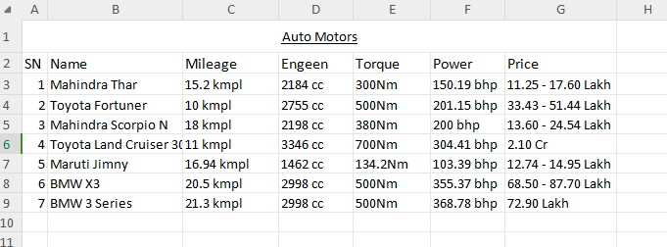

**RESULTS AND DISCUSSION :**

The experiment was successful to creating list of auto motors using MS Excel. The table contains name vehicle, its mileage, Engeen size, torque, Power, and their price.

**CONCLUSION :**

This laboratory exercise provided a hands-on experience in creating list using MS Excel. Students gained practical knowledge of the basic in MS Excel.